Livability and Sustainability of Hong Kong Redevelopment

Name:
Institution:
Course:
Institution:

ABSTRACT
Open design building is a fundamental requirement for the achievement of a livable and sustainable urban development. To understand these concepts, this paper will explore the level of redevelopment plans in Hong Kong. The paper aims at examining the livability of redeveloped Hong Kong, identification of challenges to the sustainability of redeveloped areas, and strategies to improve future redevelopment plans to achieve the smart city initiatives. The results obtained from different publications show that the stakeholders have varied opinions on governance, environmental conditions, physical conditions, and socioeconomic sector. Based on the findings, important indicators for livability and sustainability are adequate social amenities, social cohesion, ease of doing business, and better lifestyles. Social amenities are places where members of the community can converge to access different services, including shelter, food, educational, health, and psychosocial services, and water and sanitation.
Social amenities allow people to access affordable education, healthcare, and employment, which are vital for their wellbeing. Social cohesion is the connectedness of members of society and focuses on the establishment of a sense of belonging and relationships between community members. Social cohesion can be promoted through eradication of discrimination, upward social mobility, and social capital. Better lifestyles will be achieved through recycling, relying on renewable energies, reducing water and food wastage, and pollution. Also, they can be achieved by the improvement of healthcare services, access to information, transport, education, and employment..
Keywords: Livability; Sustainability; Urban Form; Aesthetic Value; Social Infrastructure.

INTRODUCTION
Over the last two decades, the urban population across the globe has increased significantly because of continued rural-urban migration, higher birthrates and lower death rates, expansion of urban areas, and better employment opportunities. By the beginning of the 21st century, the urban population will be more than 45% of the global population (Xue, 2016; Ng, 2002). Research shows that by 2050, the urban population will have exceeded 70% of the global population. An increasingly urban population prompts city developers to use techniques that will promote sustainability and achieve the smart city initiative. However, the achievement of the smart city initiative can be faced by challenges like increase urban population, inadequate resources like available fresh water and land, political instability, and social unrest.
Having future redevelopment plans for Hong Kong is important because it will provide leaders with a blueprint on how to optimally allocate resources, including capital, water, and land in areas that require redevelopment. Awareness of this information can help leaders address the problems of Hong Kong residents and develop a sustainable city for future generations. Xue (2016) argues that this information can be used to make reliable and informed decisions about redevelopment. Livability and sustainability in Hong Kong are affected by numerous challenges, including volatile regional and international dynamics, increased urban population, demand for quality lifestyles, demand for social infrastructure, and inadequate land resources (Xue, 2016). Social infrastructure in this context is used to mean the services and infrastructure designed to improve the quality of life. They include education, transport, healthcare, public spaces (parks), and arts and culture.
Research indicates that different success strategies can be employed to promote a sustainable Hong Kong and improve its sustainable city index. These strategies should be designed to improve ease of doing business, promote economic development, increase employment rates, flexibly design a city's infrastructure, and ensure that they meet the needs of the growing population, advancing technology, and scientific developments (Hollingsworth, 2016).
Aim and Objectives
The paper aims at offering a detailed understanding of livability and sustainability in redeveloped Hong Kong. Also, the paper discusses approaches that can be used by the Hong Kong government to promote the lifestyles of residents. The objectives of the research are outlined below.
- Explore livability of redeveloped Hong Kong
- Identify challenges of sustainability in redeveloped areas
- Implement success strategies to enhance redevelopment projects
LITERATURE REVIEW
Sustainable Urban Development
The built environment is one of the most dynamic industries because changes in the industry determine the residents’ lifestyles. The evolution of urban fabric over time is crucial because it subjects a city to changing policies and decisions that dictate the structure, urban form, and livability (Ng, 2002). Because of its dynamic nature, it is important to focus on constantly improving the quality of life and urban structure.
Sustainable urban development is an important concept that determines the future prosperity of cities. Rydin (2012) argues that sustainable urban development comprises equality, respect for the ecosystem, mutual relationships between humans and the environment, and demographic stability. A sustainable urban area is characterized by increased green spaces, the presence of sidewalks to prevent pedestrian vehicular crisis, more waterways to improve aesthetic value and ecosystem, and planting more trees to improve air quality. These aspects of sustainable development are indicated by good governance, built environment, and the relationship between environment and society (Ng, 2002). Good governance is important because it promotes demographic stability, diversity promotes innovation and productivity. In terms of diversity, it will focus on promoting equity and equality, easing access to loans for people in low income, and increase the affordability of houses. Management of the environment by planting more trees, recycling wastes, minimizing water wastage, green building, and rooftop gardens to alleviate pollution, use resources effectively, and protecting the ecosystem by minimizing the use of chemicals in agriculture, improving roads to promote public transportation, developing bike paths and walkways, promoting organic farming, and using renewable energies lead to the achievement of sustainable development.
To successfully address problems of sustainability, the Hong Kong government implemented the smart city initiative, which aims at using digital technologies to promote quality lifestyles for Hong Kong residents, promote safety, city management, address urban problems, livability, and sustainability (Smartcity.gov). Digital technologies improve lifestyles because residents can access information and knowledge on how to live better. These technologies promote the use of green energy because they can be used to assess the levels of greenhouse gases in the atmosphere and predict the best approach to alleviate them. Technologies can improve healthcare because healthcare providers can access patient information electronically and easily, which helps in effective diagnosis. Also, technologies can be used to share information between professionals, thus promoting collaborative healthcare. Through this initiative, the city has adopted green energy, building, promoted continuous economic development, governance, and improved healthcare. Despite these improvements, sustainable urban development remains underdeveloped.
Sustainability has been achieved in Hong Kong by the continuous infrastructural developments, complex road networks, and flexible urban fabric. Over 95% of Hong Kong residents can access public transportation, which is affordable and convenient (Xue, 2016). Vehicular and pedestrian conflicts have been alleviated. Improving the aesthetic value, a distinct skyline, and integration of nature and artificial beauty make the city unique. According to the city’s Planning Department (2016), redeveloping urban areas will promote social mobility. Hong Kong has green spaces, which account for approximately 75% of the city’s territory. Examples of green spaces can include Victoria Peak Garden, Jordan Valley Park, and Hong Kong Park. The city’s population, therefore, is squeezed in the remaining 25%, implying that most of the people occupy tiny spaces. Also, to accommodate for such a large population, the city has many sky scrappers and complex buildings, which have residential areas, offices, shopping malls, and medical centers. This approach means that people do not travel much, thus limiting carbon emissions, which in turn promotes environmental protection.
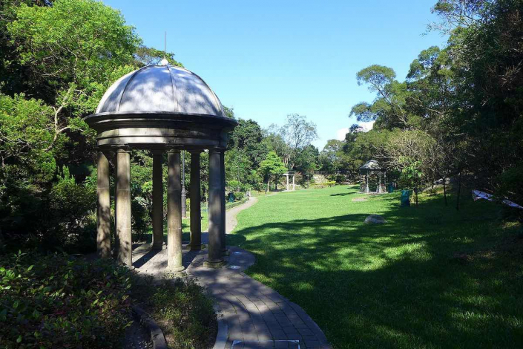
Figure 1: Victoria Peak Garden
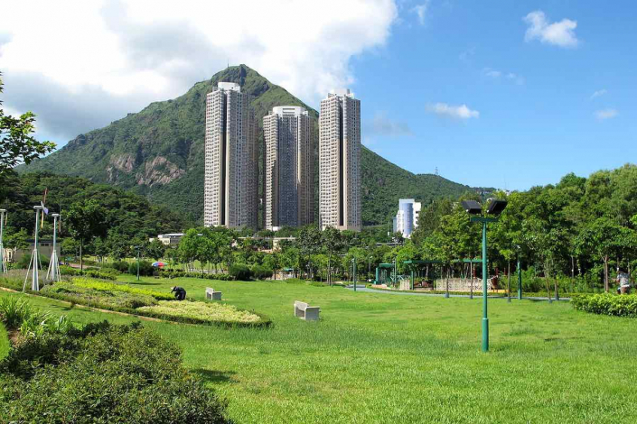
Figure 2: Jordan Valley Park
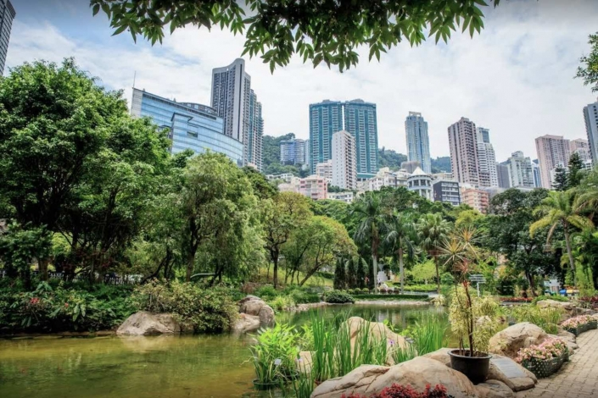
Figure 3: Hong Kong Park
Challenges Facing Sustainability
The main challenges that Hong Kong faces include a poor balance of investments in people and profits, rapidly changing demographics, poor air quality, scarce land resources, high housing demand, an overburdened healthcare system, and climate change (Cheung, 2017).
The population of the city is over 7.5 million and is expected to surpass 8 million by 2041. Increased population leads to increased pollution, housing demand, and vehicular-pedestrian conflicts. Living in Hong Kong is expensive, based on a survey to determine sustainability rankings, it was ranked 81st in terms of work-life balance, affordability, and income inequality (Zang et al., 2018). This means that Hong has poor work-life balance, life is expensive, and the wage gap is large. Poor air quality and lack of enough clean water are other challenges in the city. The proximity to a highly industrialized mainland has led to the deterioration of the city's air quality. Pollution of the city’s main source of water, Dongjiang River, which contributes about 80% of the city’s water, has increased demand and cost. The increased population of old people has overburdened healthcare institutions. Due to overreliance on fossil fuels, the adoption of renewable energies is still a challenge leading to increased pollution ( Zhang et al., 2018). Majority of the industrial processes still use fossil fuels, transportation, and domestic energy use, meaning that the levels of carbon emission are still high.
Strategies to Promote Future Hong Kong Redevelopments
The first step by the city is to redevelop old urban areas, including Fanling North, Kwu Tung, and Hung Shui Kiu (Cheung, 2017). Redeveloping these areas will open up new areas for offices, residential areas, and shopping centers, which is consistent with the smart city initiative (Bai et al., 2020). Increasing public housing units and lowering the prices will benefit populations of all economic classes. This approach will minimize housing demand. Expansion of healthcare facilities will minimize healthcare burden in the city. The adoption of green energy and green building will help address power demand in the city. Further, the government can focus on improving cultural facilities to promote diversity, nurture talents, and innovation.
METHODOLOGY
Descriptive research methods were used to describe the current livability and sustainability status in redeveloped Hong Kong. Data was collected by surveying public, private and the civil society sectors and conducting archival research. The information that was collected from government publications, records, and journals focused on addressing governance, social integration, diversity, level of employment, social infrastructure, the built environment, and economic prosperity.
RESULTS AND DISCUSSION
Table 1: The level of livability and sustainability in different sectors in Hong Kong
Sector | Urban redevelopment | Urban structure | Planning and design | Aesthetic value | Urban transport
members of society | 3.5 | 2.9 | 3.6 | 4.8 | 4
public sector | 4 | 4.5 | 4.3 | 5 | 5
private sector | 3 | 3.6 | 3.2 | 4.6 | 4.3
mean | 3.5 | 3.7 | 3.7 | 4.8 | 4.4
standard deviation | 0.4082 | 0.6557 | 0.4546 | 0.1633 | 0.4203
p-value | 0.00 | 0.00 | 0.00 | 0.00 | 0.00

Results show that the public sector (the city’s leadership) scored the highest in urban redevelopment, urban structure, planning and design, aesthetic value, and urban transport. In terms of urban redevelopment, the public sector scored 4, private sector 3, and members of society 3.5. These results are consistent with the arguments of the Planning Department (2016) on the achievement of vision 2030. In urban structure, the public sector scored 4.5, .6 for the private sector, and 2.9 for members of society. In planning and design, the public sector scored 4.3, the private sector 3.2, and members of society 3.6. In terms of aesthetic value, the public sector scored 5, the private sector 4.6, and members of society 4.8. This finding is consistent with the guidelines of the smart city initiative (Smatcity.gov). In urban transport, the public sector scored 5, private sector 4.3, and members of society 4.
LIMITATIONS
During the research, several limitations were encountered. The results of the survey were sent by mail, exposing the data to the risk of loss or manipulation. The data can also be bias because of manipulation to make one sector look better than the others. the results cannot be generalized because they focused on a limited number of participants from three sectors.
FUTURE DIRECTIONS
In the future, it is necessary to conduct further research to help members of society, the public, and private sectors understand successful strategies to promote livability and sustainability. Knowledge of challenges facing the city can be used to help in decision-making and improvement of the built environment.
CONCLUSION
Promoting livability and sustainability in cities is crucial because it helps address challenges associated with the increased urban population. This research aimed at exploring livability and sustainability in redeveloped Hong Kong. Also, the paper discussed approaches that can be used by the Hong Kong government to promote the lifestyles of residents. Challenges facing Hong Kong include a poor balance of investments in people and profits, rapidly changing demographics, poor air quality, scarce land resources, high housing demand, an overburdened healthcare system, and climate change. These challenges can be addressed by employing strategies like the adoption of green building and energy, expansion and increased funding of the healthcare system, improvement of cultural facilities, and the smart city initiative.

References
Bai, Y., Song, J., Wu, S., Wang, W., Lo, J.T.Y., & Lo, S.M. (2020). Comparing the Impacts of Location Attributes on Residents’ Preferences and Residential Values in Compact Cities. A Case Study of Hong Kong. Sustainability. 12(4867. Doi:103390/su12124867
Cheung, M. (2017). HK developing a smart city. https://www.news.gov.hk.html
Hollingsworth, J. (2016). “Hong Kong must focus on ‘liveability’ to improve its sustainability ranking.” South China Morning Post. Retrieved from https://amp/scmp.com/business/article/2020920/hong-kong-must-focus-liveability-improve-its-sustainability-ranking
Smartcity.gov (2020). HKSMART CITY BLUEPRINT. Retrieved from https://www.smartcity.gov/hk/
Ng, M. K. (2002). “Sustainable Urban Development Issues in Chinese Transitional Cities: Hong Kong and Shenzhen,” International Planning Studies, 7(1), Pp. 7-36.
Planning Department (2016). Planning and Urban Design for a Livable High-Density City. Hong Kong 2030+. https://www.hk2030plus.hk/document/
Rydin, Y. (2012). Governing for sustainable urban development. Routledge.
Xue C. Q. L. (2016). Hong Jong Architecture 1945-2015: From Colonial to Global. Internet Resource.
Zhan, D., Kwan, M. P., Zhang, W., Fan, J., Yu, J., & Dang, Y. (2018). Assessment and determinants of satisfaction with urban livability in China. Science of the Total Environment. 79 (6), Pp. 92-101.

